DISTRICT GIS · PARAKH
User Manual
Indore Inspection Forms — Web (District GIS Parakh)
Phase 1 — Step-by-Step, Screen-by-Screen Walkthrough by User Role
Version 1.0 — Phase 1
Indore Collectorate | District GIS Parakh (MPSSDI)

Contents

About This Manual
This manual documents the Phase 1 workflow of the Indore Inspection Forms module inside District GIS Parakh, as walked through on the UAT environment. It is organised sequentially, screen by screen, in the order a new deployment is actually set up and used — from the first System Admin login, through Department Reporting Officer (HOD) and Inspector creation, to inspection review, action-taking and Collectorate-level monitoring.
Each step states the Role Assigned (who performs it) and the Activity Performed (what they do on that screen), alongside the actual screen captured during the walkthrough.

Access URLs
- UAT: https://gisuat.mp.gov.in/parakhweb/
- PROD: https://geoportal.mp.gov.in/parakhweb/

Roles at a Glance
Four roles participate in the Phase 1 workflow. Each is created by the role above it in the hierarchy, and each has a distinct scope of activity:
Role | Created By | Primary Activities
State Admin  (Indore Collectorate Admin) | Pre-provisioned (system level) | Creates Nodal Officers and Reporting Officers (Department HODs); views registered-user counts and inspection statistics across every department; reviews the General Form Report across all departments.
Nodal Officer | State Admin | Acts as the Collector's monitoring representative; views the General Form Report read-only, across all departments, for district-level oversight.
Reporting Officer (RO) / Department HOD | State Admin | Owns one Department & Sub-Department; creates Inspectors/Surveyors under that department; reviews submitted inspections for the department and Verifies or Rejects each one with remarks.
Inspector / Surveyor | Reporting Officer | Conducts the field inspection and submits the department-specific checklist against an asset/institution.

Part A — System Access & State Admin Setup

Step 1. Open the Application
Screen / URL: https://gisuat.mp.gov.in/parakhweb/ (UAT) / https://geoportal.mp.gov.in/parakhweb/ (PROD)
ROLE ASSIGNED: Anyone with issued credentials (State Admin, for this walkthrough)
ACTIVITY PERFORMED:
- Open the UAT or PROD URL of District GIS Parakh in a browser.
- On the landing page, choose the Department login tile (as distinct from Citizen and Vendor/Agency logins).
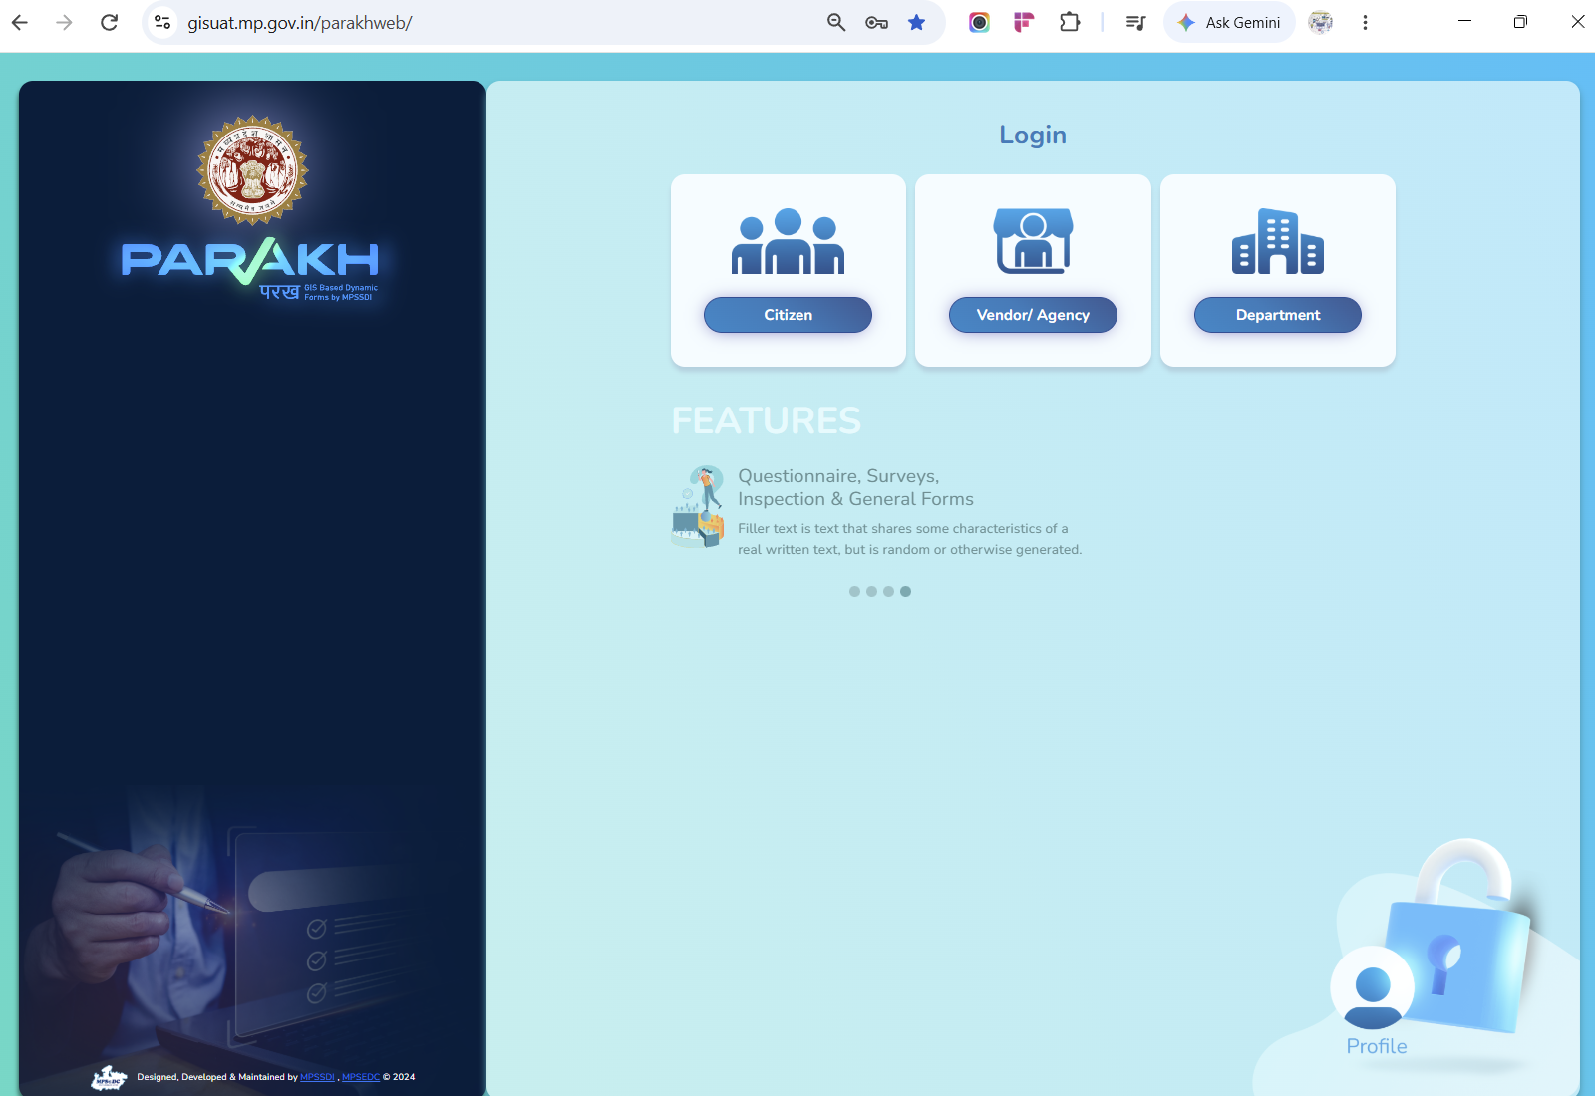
Screen 1 — District GIS Parakh landing page: Citizen / Vendor-Agency / Department login options

Step 2. Department Login
ROLE ASSIGNED: State Admin (Indore Collectorate Admin)
ACTIVITY PERFORMED:
- Enter the department-level username and password in the Department Login pop-up and click Login.
- Example credentials used in this walkthrough — Username: indorecollectorateadmin, Password: Test@123.
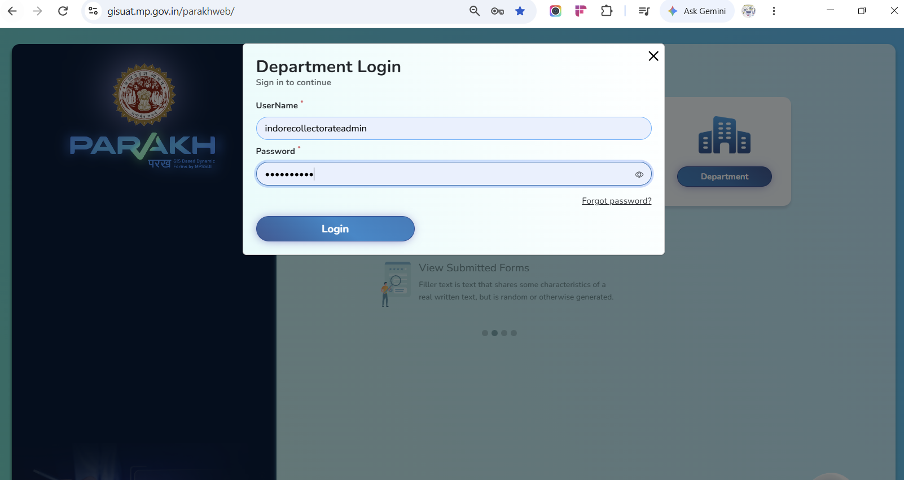
Screen 2 — Department Login pop-up

Step 3. State Admin Dashboard
Screen / URL: /parakhweb/SuperAdminDashboard
ROLE ASSIGNED: State Admin
ACTIVITY PERFORMED:
- On successful login, the State Admin lands on the Indore Collectorate dashboard.
- The dashboard shows a live count of all registered users by role — State Admin, Nodal Officer, Reporting Officer and Inspector — plus panels for Inspection/Survey statistics, tabular and graphic views of inspections, and inspection frequency.
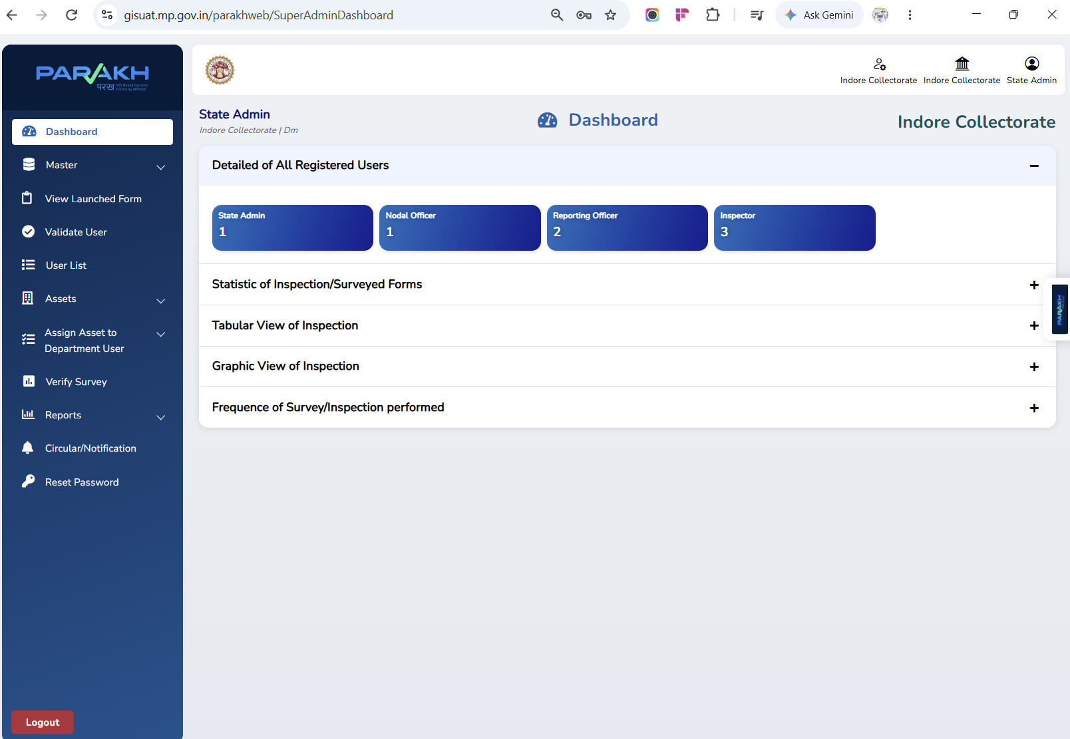
Screen 3 — State Admin dashboard, Indore Collectorate

Step 4. Check the User List Before Creating a New User
Screen / URL: /parakhweb/Userlist (Master → User List)
ROLE ASSIGNED: State Admin
ACTIVITY PERFORMED:
- Before creating a new Reporting Officer, the State Admin checks Master → User List, filtering by Department Name and User Type/Role, to confirm whether the department already has a Reporting Officer mapped.
- The screen below shows two Reporting Officers already registered — one for the Farmer Welfare and Agricultural Development Department (Sub-Department: Directorate Farmer Welfare and Agriculture Development) and one for the School Education Department.
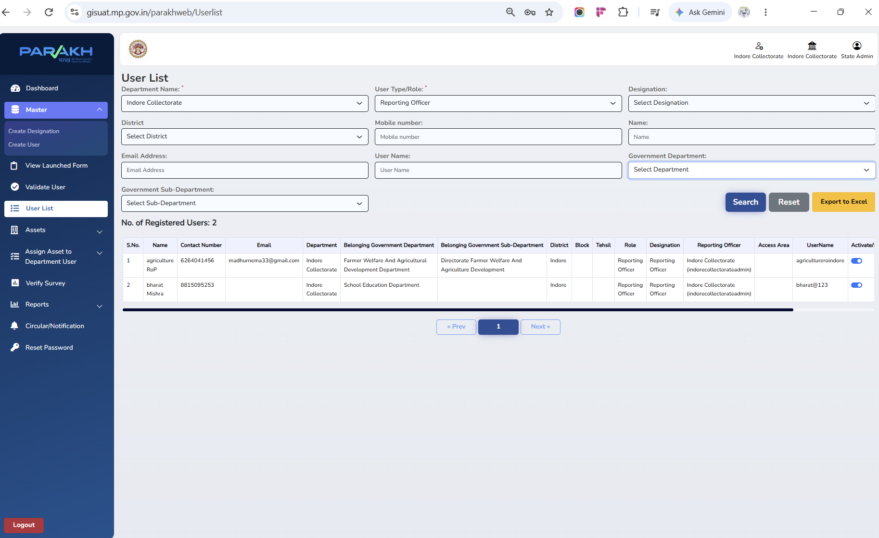
Screen 4 — User List, filtered to Reporting Officers under Indore Collectorate

Step 5. Add User — Create a Reporting Officer (Department HOD)
Screen / URL: Master → Create User
ROLE ASSIGNED: State Admin
ACTIVITY PERFORMED:
- Navigate to Master → Create User and complete the Add User form.
- Set User Type/Role to Reporting Officer and Designation to Reporting Officer.
- Select the Belongs to a Government Department and Belongs to a Government Sub-Department drop-downs to map this RO to the correct department (e.g. Higher Education Department → Rastriya Vidhi Sansthan, as shown).
- Fill District, Tehsil, Block and Urban/Rural to define the RO's jurisdiction, then click Add User.
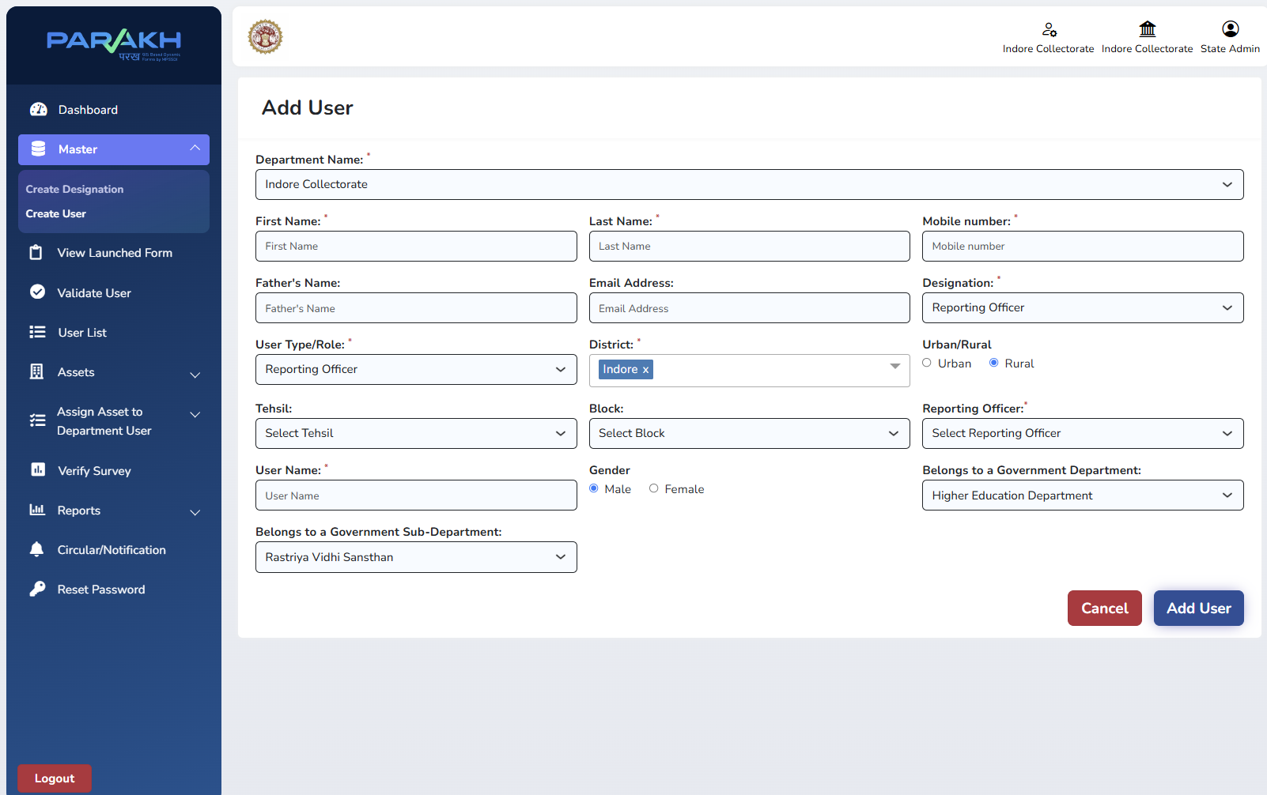
Screen 5 — Add User form: Reporting Officer mapped to Department & Sub-Department

Step 6. Verify the Reporting Officer in the User List
ROLE ASSIGNED: State Admin
ACTIVITY PERFORMED:
- Return to Master → User List and search/filter to confirm the newly created Reporting Officer appears with the correct Department, Sub-Department, District and Designation.
- The list can be exported to Excel for offline record-keeping using the Export to Excel button.
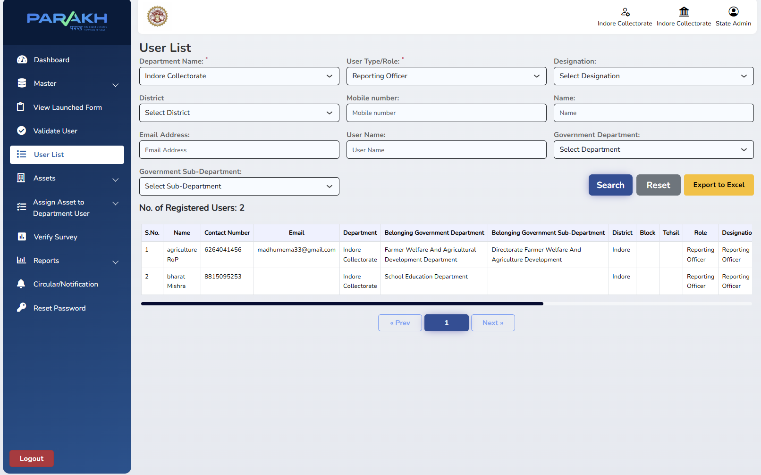
Screen 6 — User List confirming the Reporting Officer record

Part B — Reporting Officer (Department HOD): Department Setup

Step 7. Reporting Officer Login
ROLE ASSIGNED: Reporting Officer (Department HOD)
ACTIVITY PERFORMED:
- The Reporting Officer logs in with the department-specific credentials issued by the State Admin — for example, Username: agricultureroindore, Password: Test@123, for the Agriculture department RO used in this walkthrough.
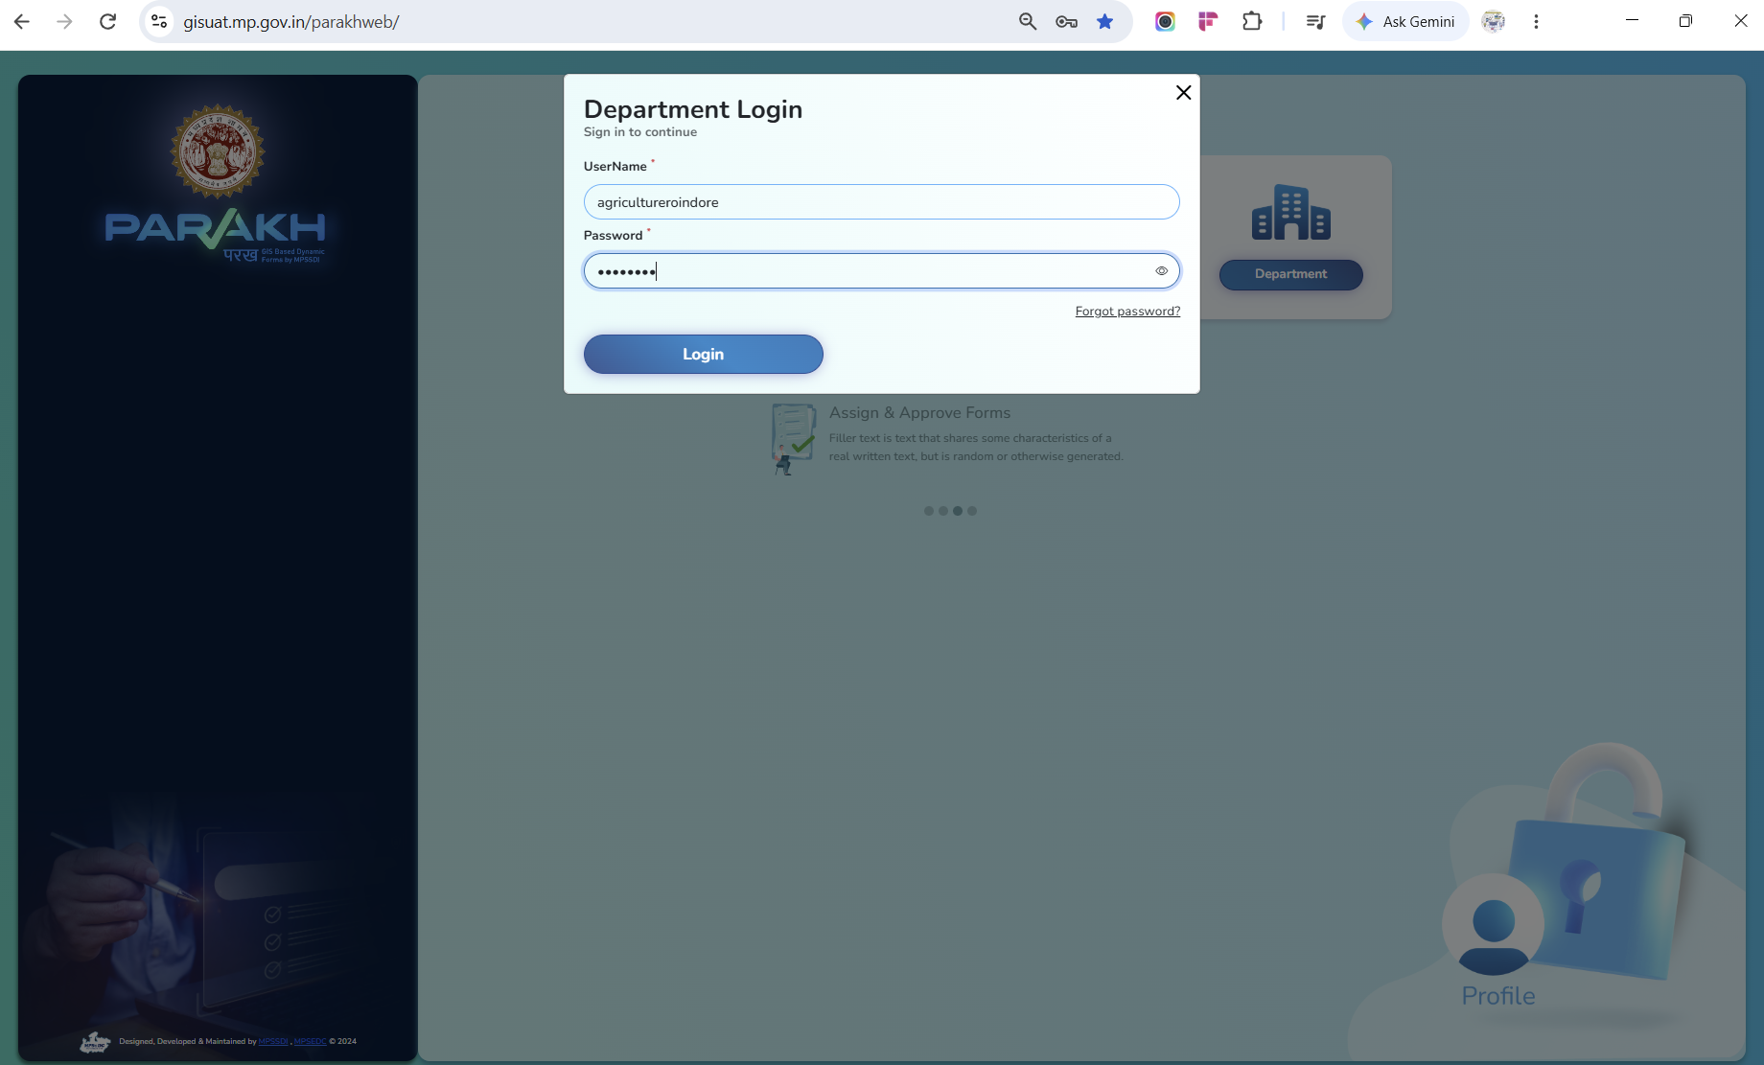
Screen 7 — Department Login as a Reporting Officer (example: Agriculture RoP)

Step 8. Create an Inspector / Surveyor
Screen / URL: Master → Create User (as Reporting Officer)
ROLE ASSIGNED: Reporting Officer (Department HOD)
ACTIVITY PERFORMED:
- The RO opens Master → Create User to add the field-level Inspector/Surveyor who will conduct inspections under their department.
- Set User Type/Role to Inspector and Designation to Surveyor.
- The Reporting Officer field auto-fills to the creating RO (e.g. "agriculture RoP"), so every Inspector created here is automatically linked back to this RO.
- Select the Belongs to a Government Sub-Department (e.g. Krishi Vishwavidyalaya) and District/Block/Tehsil, then click Add User.
- A Bulk Upload Data option is also available on this screen for creating multiple Inspector records at once.
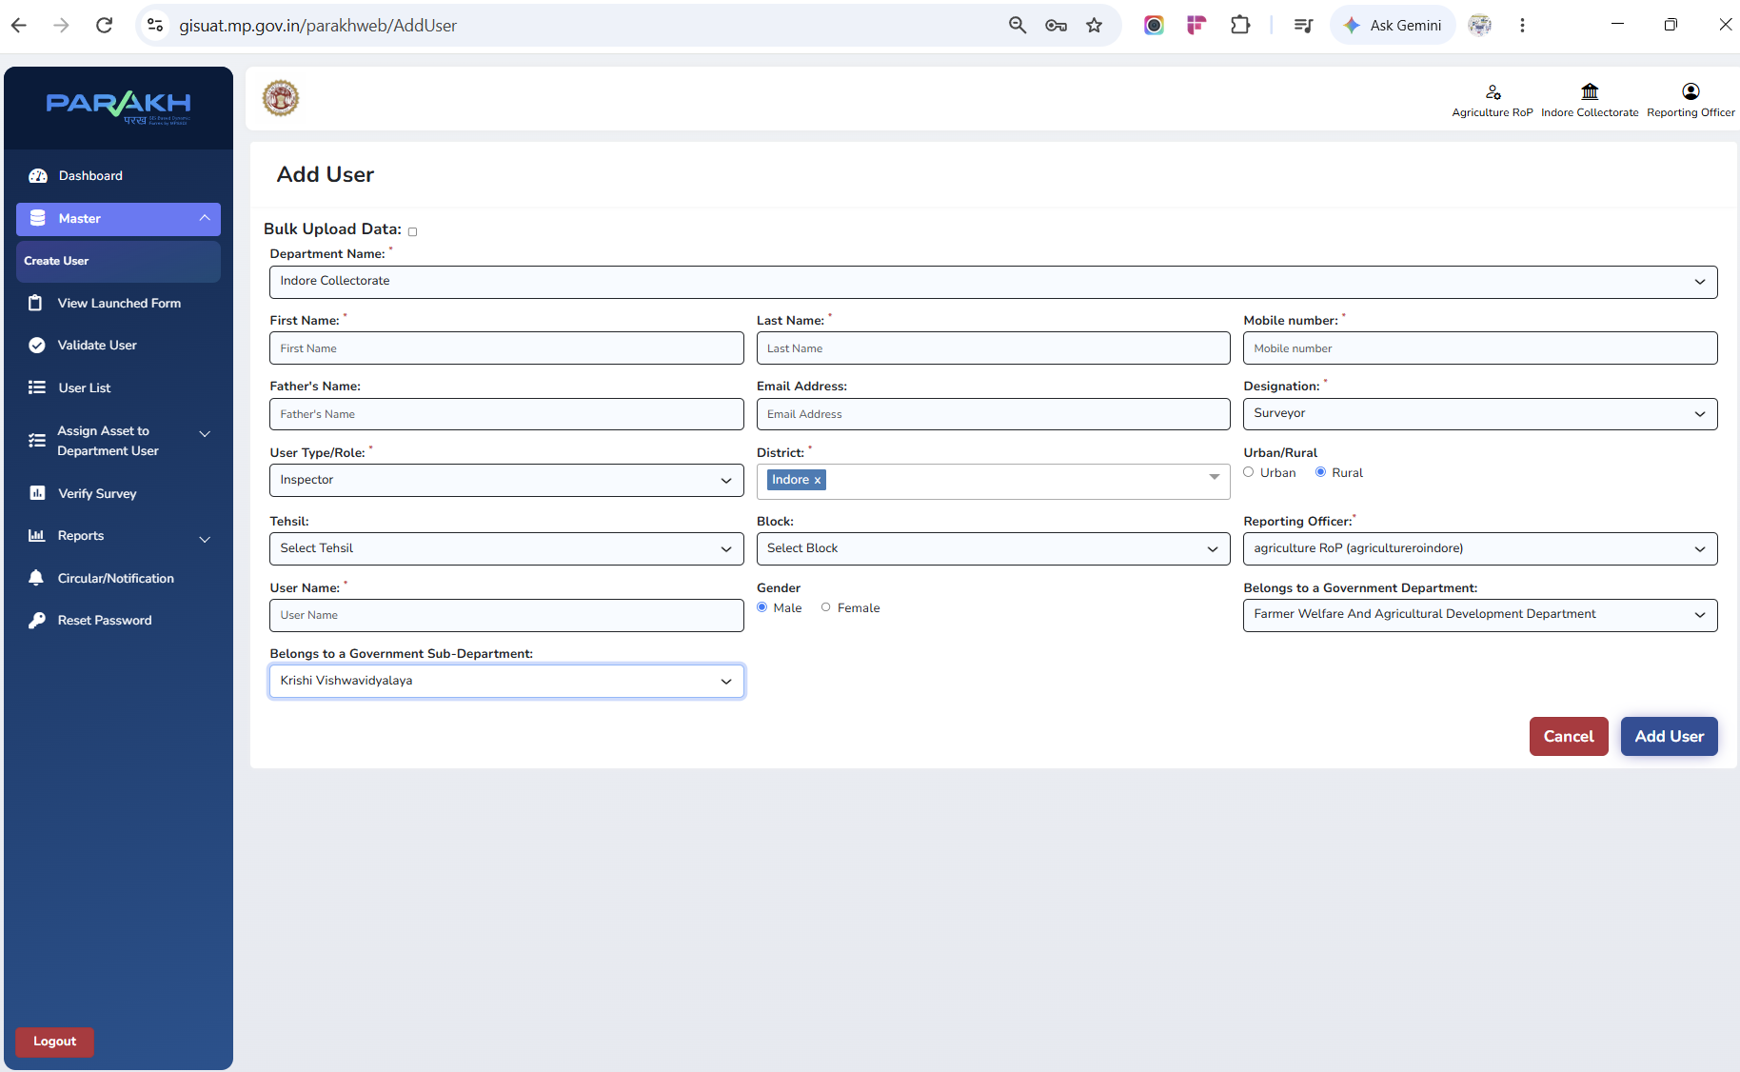
Screen 8 — Add User form: Inspector/Surveyor created under the Agriculture RO

Step 9. Preview the Department Inspection Form
Screen / URL: View Launched Form
ROLE ASSIGNED: Reporting Officer (Department HOD)
ACTIVITY PERFORMED:
- Before inspectors go into the field, the RO can open View Launched Form to preview the exact checklist that has been published for the department (here, the Agriculture Inspection Form).
- The preview shows every field the inspector will fill — Remark, Image upload, and the Yes/No checklist points (Seed stock, Fertilizer stock, Farmer services, Soil testing, Scheme implementation, Demo plots, Equipment, Field inspection, Records, and more).
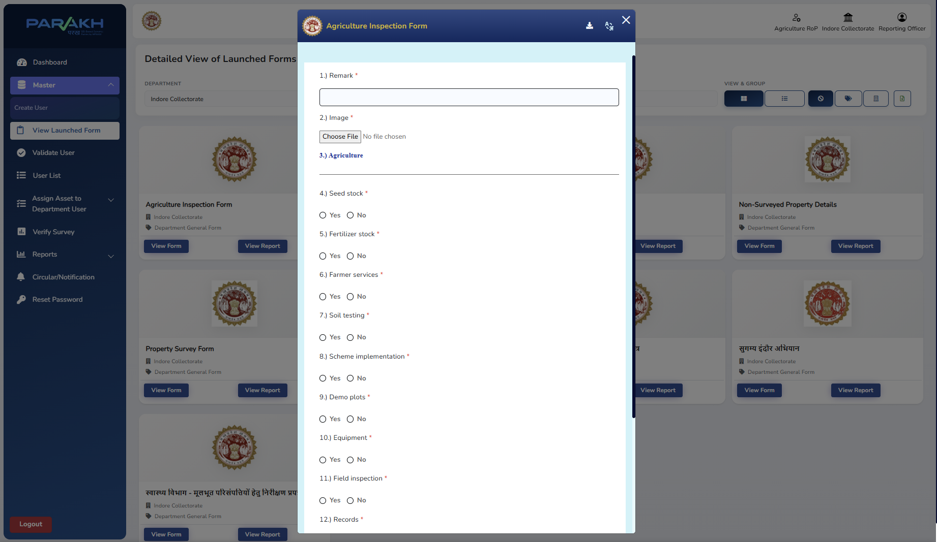
Screen 9 — View Launched Form: Agriculture Inspection Form preview, alongside other launched forms

Step 10. Verify the Inspector/Surveyor Record
Screen / URL: User List (as Reporting Officer)
ROLE ASSIGNED: Reporting Officer (Department HOD)
ACTIVITY PERFORMED:
- The RO checks User List, filtered to User Type/Role = Inspector and Designation = Surveyor, to confirm the record created in Step 8.
- Field note from this walkthrough: filtering by Department Name alone returned "No record found" — the Government Department filter (rather than Department Name) should be used to locate Inspectors mapped to a specific government department/sub-department.
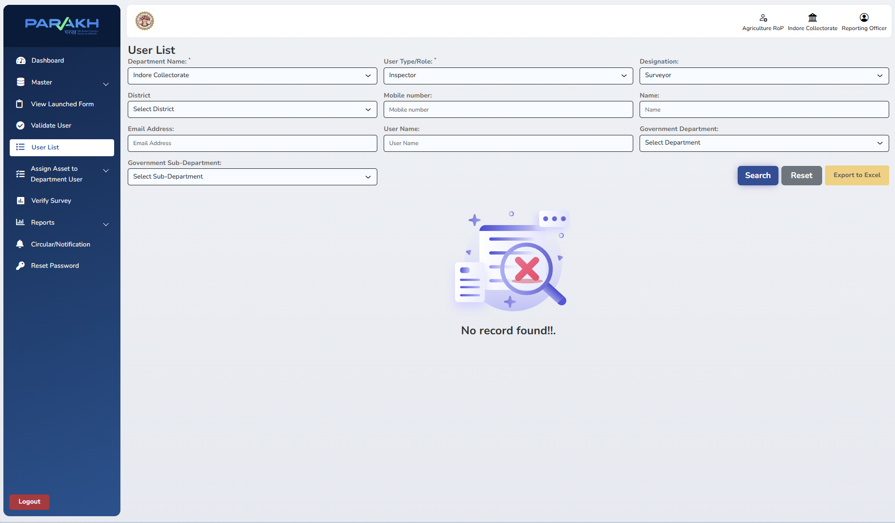
Screen 10 — User List filtered to Inspector/Surveyor (illustrates the Government Department filter dependency)

Part C — Reviewing Inspections & Taking Action

Step 11. Open the General Form Report
Screen / URL: /parakhweb/DepartmentGenReport (Reports → General Form Report)
ROLE ASSIGNED: State Admin / Reporting Officer
ACTIVITY PERFORMED:
- Navigate to Reports → General Form Report.
- The Form Name drop-down lists every inspection form currently launched. At the time of this walkthrough, nine forms were live, including four of the seventeen department checklists (Agriculture, Education, Health, Women & Child Development) plus five cross-cutting forms (Property Survey Form, Non-Surveyed Property Details, the two Sugamya Indore Abhiyan — divyang-accessibility — forms, and a generic Inspection Form).
- Select the required form to view its submitted inspections.
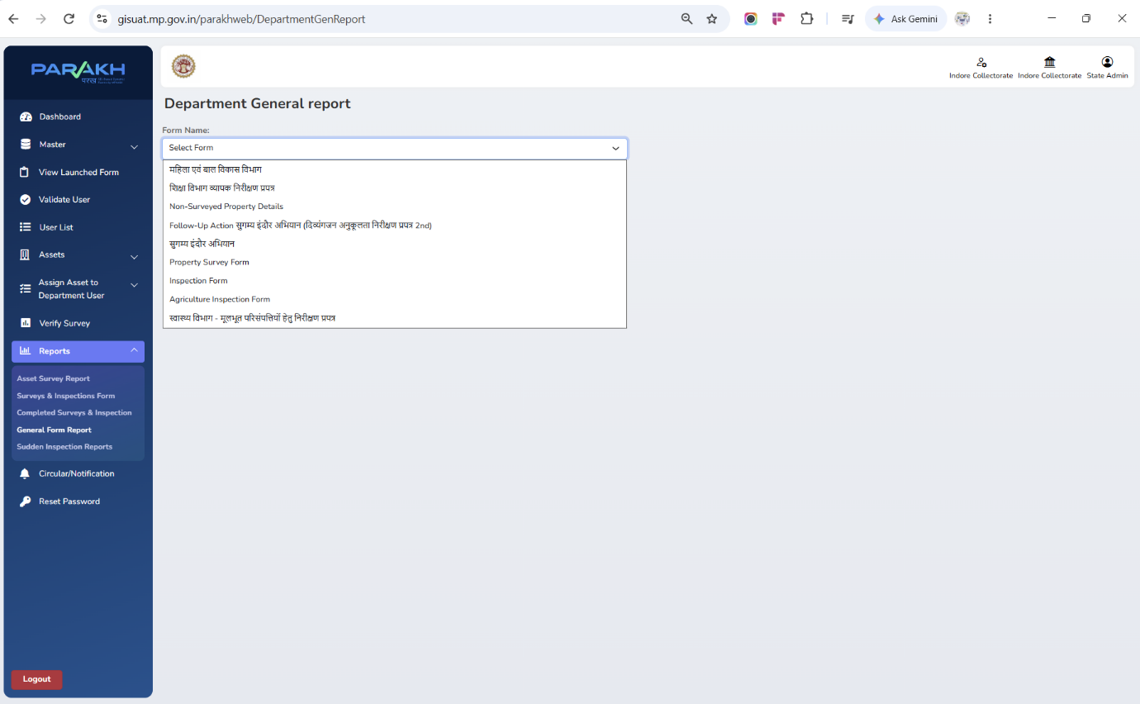
Screen 11 — Reports → General Form Report: Form Name drop-down

Step 12. Review Submitted Inspections
ROLE ASSIGNED: Reporting Officer (Department HOD)
ACTIVITY PERFORMED:
- Selecting a form (here, शिक्षा विभाग व्यापक निरीक्षण प्रपत्र — the comprehensive Education Department form) opens a filterable, tile-summarised list of submissions (Total, Primary School, Secondary School, High School, etc.).
- Each row shows the checklist answers, both photos (View), the map-view location pin, and the current Status — Submitted for new entries, or Verified By Checker once actioned.
- The RO clicks Action against any Submitted row to review and act on it.
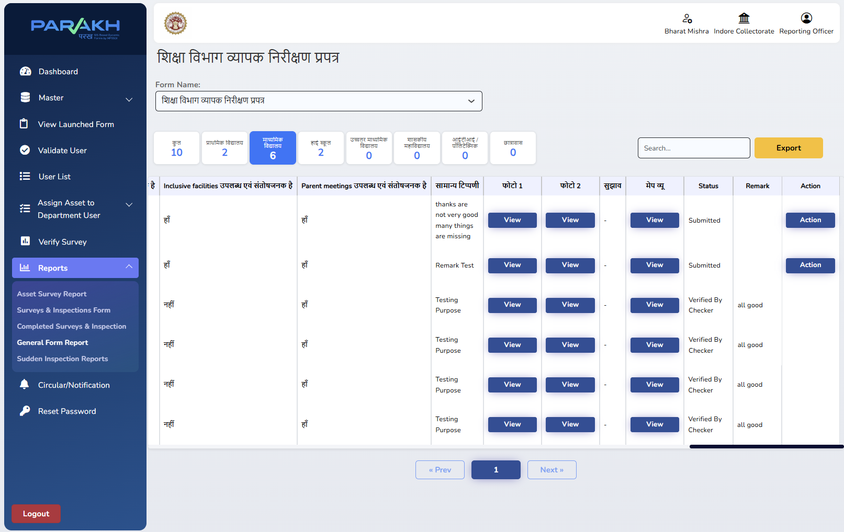
Screen 12 — General Form Report for the Education Department, RO (HOD) view

Step 13. Verify or Reject the Inspection
ROLE ASSIGNED: Reporting Officer (Department HOD)
ACTIVITY PERFORMED:
- The Verify Inspection pop-up opens with a mandatory Status field offering Verified By Checker or Reject, and a free-text remarks box.
- The RO selects the outcome, enters remarks, and clicks Submit — the record's Status and Remark update immediately in the General Form Report grid.
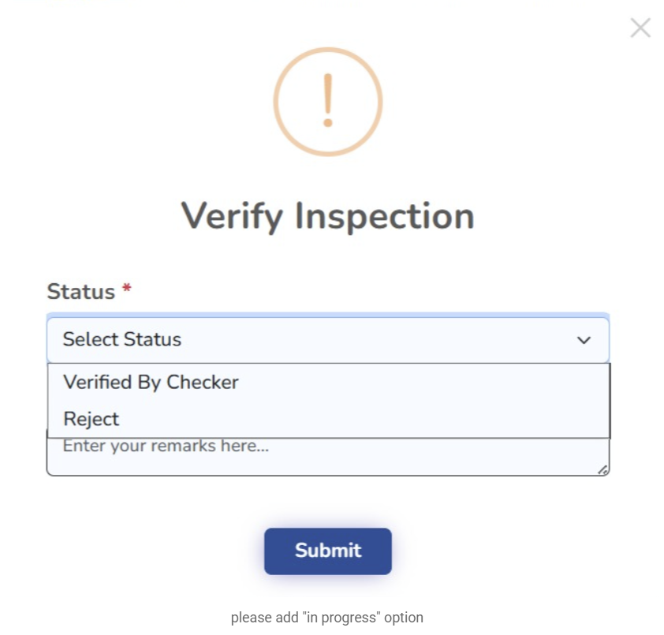
Screen 13 — Verify Inspection pop-up (Status: Verified By Checker / Reject, with remarks)
Enhancement noted during the walkthrough: an "In Progress" status option has been requested in addition to Verified By Checker and Reject, to represent inspections that are under review but not yet finalised.

Step 14. Department-Wide Status Rolls Up to State Admin
ROLE ASSIGNED: State Admin
ACTIVITY PERFORMED:
- The same General Form Report, opened under the State Admin login, shows the same submissions across the department with an additional Accept status alongside Verified By Checker — reflecting a second, Collectorate-level confirmation on top of the RO's verification.
- This gives the State Admin a consolidated, department-wide view (here, School Education Department and General Administration/State Information Commission records together) without needing a separate login per department.
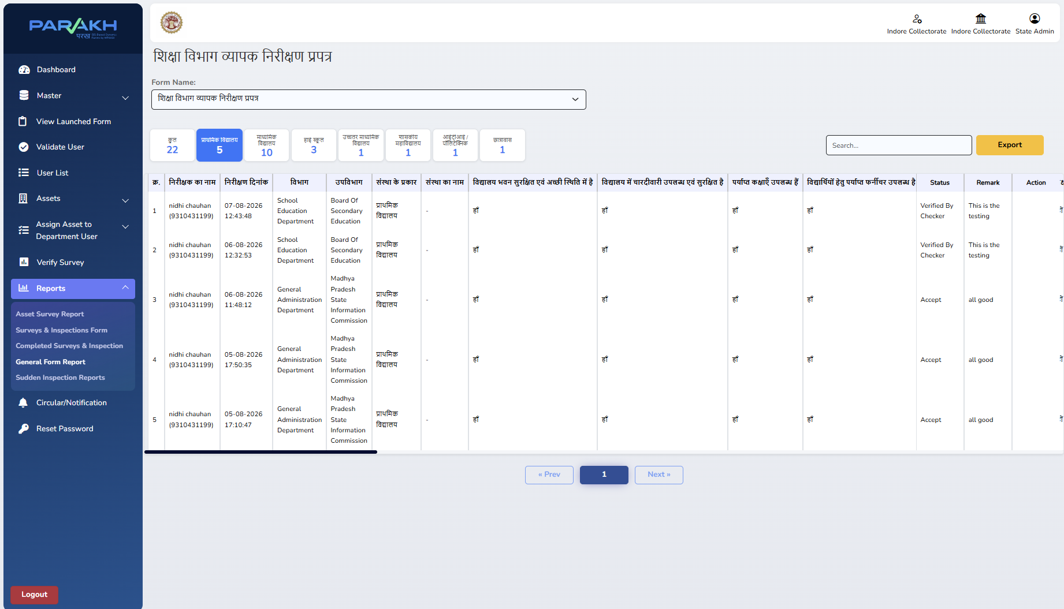
Screen 14 — General Form Report, State Admin view, showing Verified By Checker and Accept statuses

Part D — Nodal Officer: Collectorate-Level Monitoring

Step 15. Create the Nodal Officer (Collector's Representative)
Screen / URL: /parakhweb/Userlist
ROLE ASSIGNED: State Admin
ACTIVITY PERFORMED:
- The State Admin creates or verifies a Nodal Officer user — the login used to represent the Collector's office for monitoring purposes.
- In this walkthrough, "Shivam Verma" is registered as Nodal Officer under Indore Collectorate, reporting to indorecollectorateadmin, with username jc@123.
- The Activate/Deactivate toggle and Edit action are available against each user directly from this list.
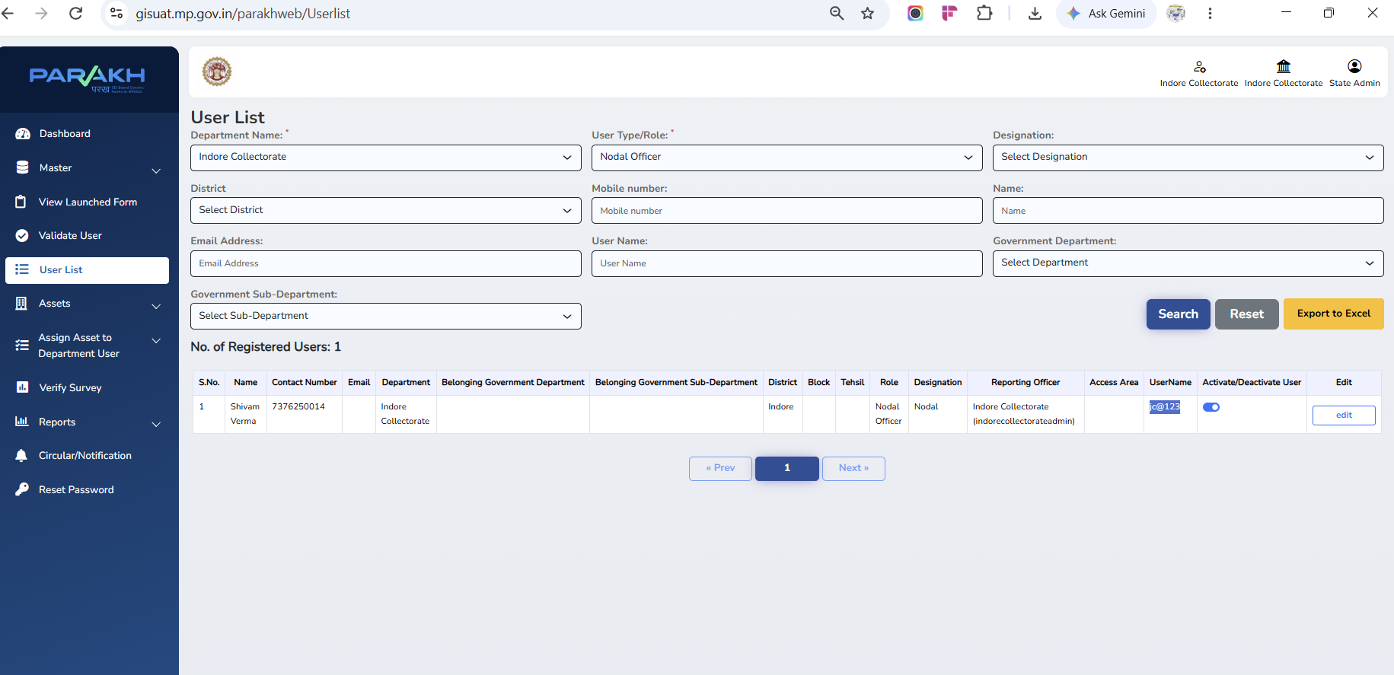
Screen 15 — User List filtered to Nodal Officer, showing the Collector's representative account

Step 16. Nodal Officer Monitoring View
ROLE ASSIGNED: Nodal Officer
ACTIVITY PERFORMED:
- Logging in as the Nodal Officer (shown top-right as "Shivam Verma … Nodal Officer") and opening the same Reports → General Form Report gives an identical, read-only view of every department's submissions and their Verified/Accepted status.
- This confirms that Collectorate-level monitoring does not require a separate reporting mechanism — it uses the same report, scoped to the Nodal Officer's login.
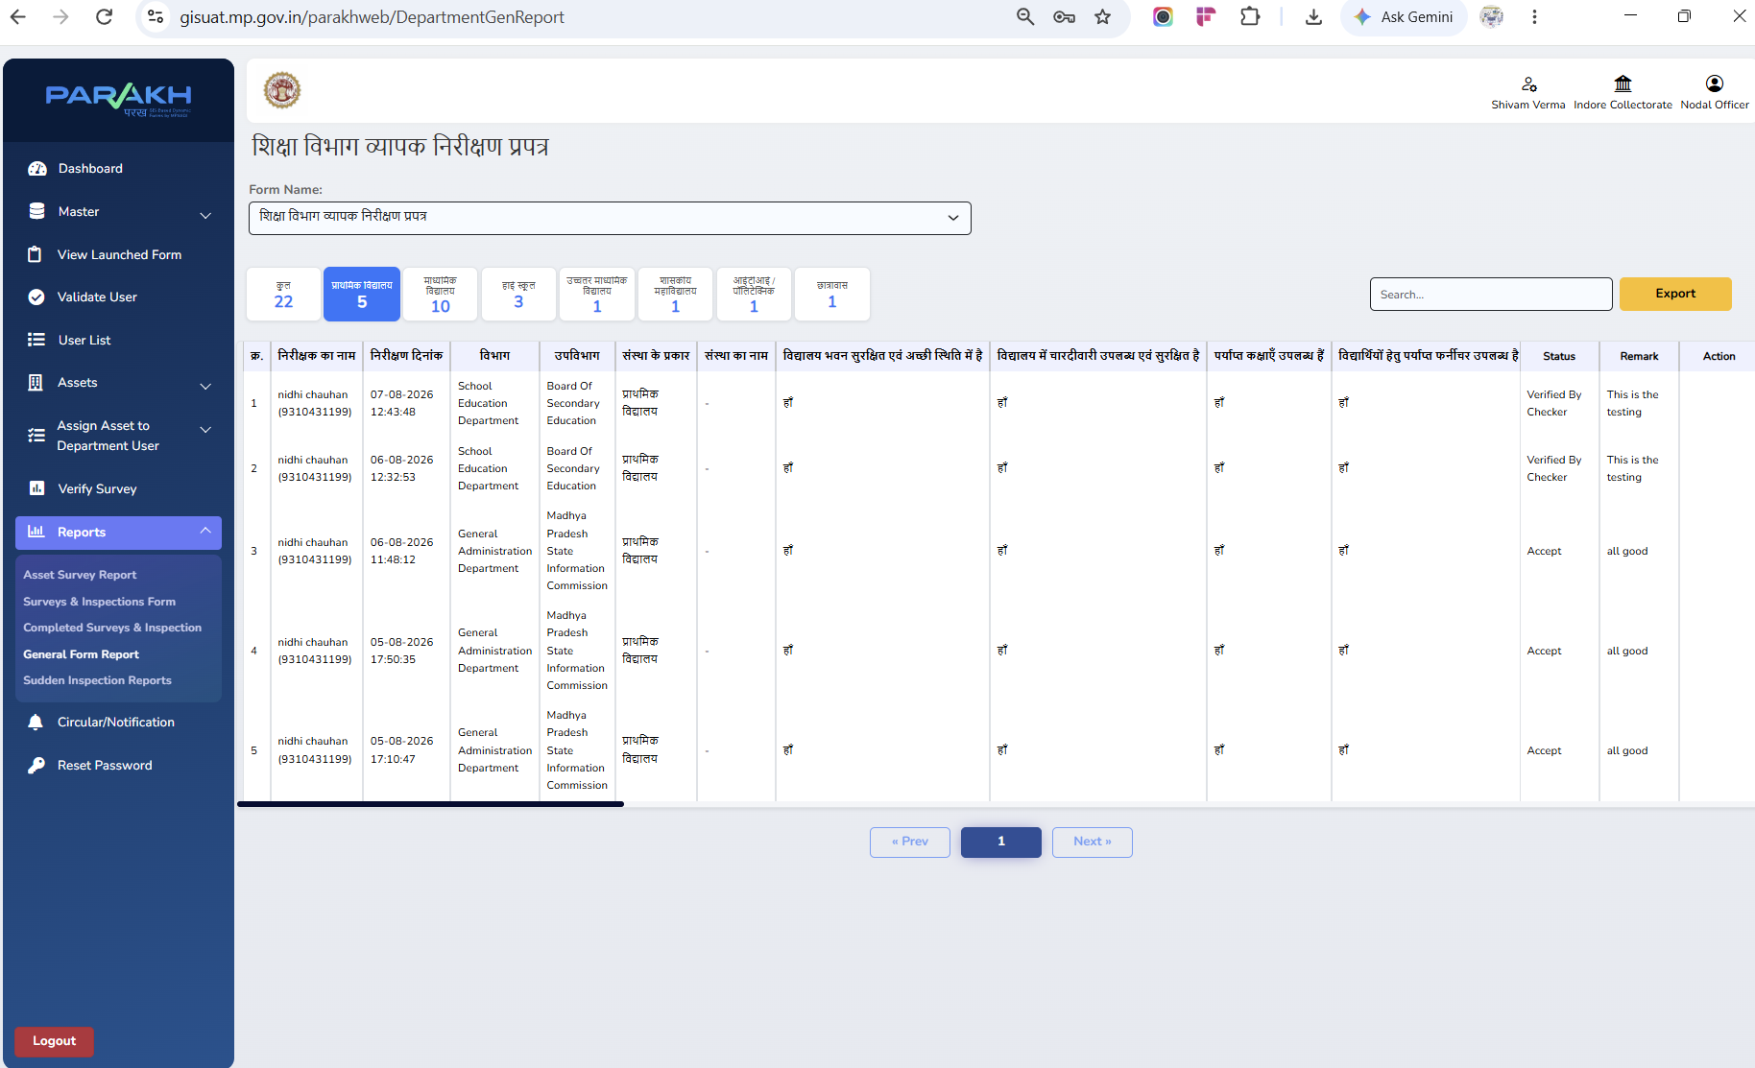
Screen 16 — General Form Report, Nodal Officer view (Collectorate monitoring)

Part E — Phase 1 Status & What's Next
As observed on UAT at the time of this walkthrough:
Capability | Status
State Admin setup, Reporting Officer creation & department mapping | Working
Inspector/Surveyor creation under a Reporting Officer | Working
Department-specific inspection forms (4 of 17 launched: Agriculture, Education, Health, WCD) | In Progress
General Form Report — submission review by Reporting Officer | Working
Verify / Reject action workflow with remarks | Working
"In Progress" status option on the Verify Inspection pop-up | Requested Enhancement
State Admin / Nodal Officer consolidated & Collectorate-level monitoring view | Working
Remaining 13 department checklists — digitisation into launched forms | In Progress

Step 17 (as noted during the walkthrough): implementation continues for the remaining department-specific inspection forms and the further action-tracking workflow. This manual will be updated as each additional department form is launched and as the Verify/Reject/In-Progress status options are finalised.

